**Student Name:** N.J.Aparnapriya

**Register Number:** 511323104005

**Institution:** Kingston engineering college

**Department:** computer science engineering

**Date of Submission:** 08-05-2025

**Github Repository Link:** https://github.com/Aparnapriya-1/N.J.Aparnapriya

### **1. Problem Statement**

In today's digital age, the widespread dissemination of **fake news** poses a serious threat to public trust, democracy, and societal stability. With the increasing reliance on online platforms for news consumption, malicious actors exploit social media and news websites to spread misinformation at an unprecedented scale. This not only misleads individuals but also affects political decisions, public health responses, and social harmony.

To combat this growing menace, we aim to develop a **fake news detection system** powered by **natural language processing (NLP)** techniques. The system will automatically analyze the textual content of news articles or social media posts and determine whether the content is **genuine or fake**.

This is a **binary classification problem**, where each news item is labeled as either real or fake. The model will be trained on labeled datasets using machine learning or deep learning algorithms in combination with NLP methods such as tokenization, TF-IDF, word embeddings, and transformers (e.g., BERT).

### Importance and Business Relevance:

* **Media Platforms**: Helps news agencies and social media platforms filter out misinformation before it reaches mass audiences.
* **Government & Law Enforcement**: Assists in identifying harmful propaganda or coordinated misinformation campaigns.
* **Corporate Reputation Management**: Protects businesses from the spread of false narratives that can damage brand image.
* **Public Trust**: Builds user trust by promoting reliable content and curbing false claims.

### **2. Abstract**

In an era dominated by digital communication, the rapid spread of fake news has emerged as a significant societal and technological challenge, threatening public trust and informed decision-making. This project aims to develop an advanced fake news detection system using **natural language processing (NLP)** to automatically identify and flag deceptive or misleading news content. The primary objective is to classify news articles as either *real* or *fake* based on their textual content.

To achieve this, the system will leverage NLP techniques such as text preprocessing, TF-IDF, word embeddings, and transformer-based models like BERT for feature extraction and classification. A range of machine learning and deep learning models will be trained and evaluated on publicly available labeled datasets. The system will be assessed using accuracy, precision, recall, and F1-score to ensure reliable performance. Ultimately, this project seeks to provide a scalable and effective solution to help media platforms, governments, and the public combat misinformation and promote the dissemination of truthful information.

### **3. System Requirements**

To effectively develop and run the fake news detection project, certain minimum hardware and software specifications are required.

* ***Hardware****:* On the **hardware side**, a system should have at least **8 GB of RAM** and a **multi-core processor (Intel i5/Ryzen 5 or higher)**, especially when working with large datasets or training deep learning models. For more intensive transformer-based models like BERT, **GPU support** (via Google Colab or a local CUDA-enabled GPU) is highly recommended to accelerate training.
* ***Software****:* On the **software side**, the project will be developed using **Python 3.8 or later**, along with essential libraries such as **NumPy**, **pandas**, **scikit-learn**, **NLTK**, **TensorFlow** or **PyTorch**, and **transformers** from Hugging Face. The development environment will be **Google Colab** (for cloud-based GPU support) or **Jupyter Notebook** (for local experimentation and visualizations).

### 

### **4. Objectives**

The primary objective of this project is to accurately detect whether a given news article or social media post is real or fake based solely on its textual content. The expected outcome is a classification label for each input—either "fake" or "real"—with high accuracy, precision, and recall. By automating the detection of misinformation, this project aims to support content moderation on digital platforms, improve the quality of news consumed by the public, and ultimately mitigate the harmful effects of fake news on society, governance, and public discourse. This aligns directly with the business need to build trustworthy online ecosystems and uphold the credibility of digital media.

**5. Flowchart of Project Workflow**

* ***Insert image of your flowchart*** *]*

1.Source of Data

2. Type of Data

3. Size and Format

**Data Collection**

1. Handling Missing

Values

2. Removing Duplicate

3. Train-Test Splits3. Text Cleaning7. Label Encoding (if needed)

**Preprocessing**

**EDA**

1.TF-IDF

2.Word Embeddings

**Feature Engineering**

**1.Baseline Models**

**2.Advanced Models**

**Modeling**

**Evaluation**

**Deployment**

### **6. Dataset Description**

### The dataset used in this project is publicly available on **Kaggle**, titled “Fake and Real News Dataset.” It is a **public dataset** that contains news articles labeled as either fake or real. The dataset has approximately **40,000 rows** and includes columns such as title, text, subject, and label. The label column serves as the target variable, where "1" typically represents fake news and "0" represents real news. A screenshot of df.head() will display the first few records, giving an idea of the structure and contents of the data.

### **7. Data Preprocessing**

Data preprocessing begins with **handling missing values** by removing records with null entries in critical fields such as the news text or label. **Duplicate records** are dropped to prevent bias, and outliers are not common in text data but could be handled by removing unusually short or long articles. **Text cleaning** includes removing punctuation, stopwords, special characters, and converting all text to lowercase. Tokenization, stemming/lemmatization, and vectorization (using TF-IDF or word embeddings) are applied next. Screenshots of the data before and after these transformations will demonstrate the cleaning effectiveness and structure improvement.

### **8. Exploratory Data Analysis (EDA)**

In the EDA phase, visual tools such as **histograms** are used to analyze the distribution of article lengths and class balance. **Boxplots** help in spotting potential outliers based on word count. A **heatmap** of word correlations or feature relationships gives insight into patterns and key terms commonly found in fake vs. real articles. From the EDA, you may observe that fake news articles tend to use more sensational language or specific keywords. Key takeaways will include insights such as topic distribution, most frequent words, and any class imbalance present in the dataset. Screenshots of the visualizations are included for documentation.

### **9. Feature Engineering**

### Feature engineering involves the creation of new features such as the **length of the article**, **number of exclamation marks**, or **presence of all-caps words**, which can signal fake content. Feature selection is performed using techniques like **Chi-square**, **Lasso Regression**, or **feature importance from Random Forests** to retain the most informative variables. Text is transformed into numerical format using **TF-IDF**, **Word2Vec**, or **BERT embeddings**. These features are crucial because they help the model distinguish between informative and misleading patterns in language.

### **10. Model Building**

Multiple models are trained to compare performance, starting with **baseline models** like **Logistic Regression**, **Naive Bayes**, and **Support Vector Machines**, which are fast and interpretable. More advanced models such as **Random Forest**, **Gradient Boosting (XGBoost)**, and deep learning models like **LSTM** and **BERT** are also implemented. These models are chosen for their ability to capture linguistic nuance, sequence information, and contextual meaning in text. Model training outputs, such as loss curves and validation accuracy logs, are included as screenshots to show progress and performance over time.

**11. Model Evaluation**

Model performance is evaluated using multiple metrics. **Accuracy** measures the overall correctness, while **precision** and **recall** are crucial for understanding the false positive and false negative rates—especially important in fake news detection where the cost of misclassification is high. The **F1-score** balances precision and recall into a single metric. **ROC curves** and **AUC scores** show the model’s capability to distinguish between classes at various thresholds. These evaluations confirm the robustness and reliability of the model before potential deployment. Metrics are displayed with confusion matrices and visual graphs for clearer interpretation.

**12. Deployment**

<!DOCTYPE html>

<html lang="en">

<head>

    <meta charset="UTF-8">

    <meta name="viewport" content="width=device-width, initial-scale=1.0">

    <title>Advanced Fake News Detection</title>

    <style>

        body {

            font-family: sans-serif;

            margin: 20px;

            background-color: #f4f4f4;

        }

        .container {

            background-color: #fff;

            padding: 30px;

            border-radius: 8px;

            box-shadow: 0 2px 4px rgba(0, 0, 0, 0.1);

        }

        h1, h2 {

            color: #333;

            text-align: center;

        }

        textarea {

            width: 100%;

            padding: 10px;

            margin-bottom: 15px;

            border: 1px solid #ccc;

            border-radius: 4px;

            box-sizing: border-box;

            font-size: 16px;

            min-height: 150px;

        }

        button {

            background-color: #007bff;

            color: white;

            padding: 10px 15px;

            border: none;

            border-radius: 4px;

            cursor: pointer;

            font-size: 16px;

            transition: background-color 0.3s ease;

        }

        button:hover {

            background-color: #0056b3;

        }

        #result-container {

            margin-top: 20px;

            padding: 15px;

            border: 1px solid #ddd;

            border-radius: 4px;

            background-color: #f9f9f9;

        }

        #prediction {

            font-weight: bold;

            font-size: 18px;

            margin-bottom: 5px;

        }

        #confidence {

            color: #777;

            font-size: 14px;

        }

        .prediction-fake {

            color: red;

        }

        .prediction-real {

            color: green;

        }

        .error-message {

            color: orange;

            font-weight: bold;

        }

    </style>

</head>

<body>

    <div class="container">

        <h1>Advanced Fake News Detection</h1>

        <p style="text-align: center;">Enter the news article text below to analyze its likelihood of being fake or real.</p>

        <textarea id="news-text" placeholder="Paste news article text here..."></textarea>

        <button onclick="analyzeNews()">Analyze</button>

        <div id="result-container" style="display: none;">

            <h2>Analysis Result</h2>

            <p id="prediction"><span style="font-weight: bold;">Prediction:</span> <span id="prediction-label"></span></p>

            <p id="confidence"><span style="font-weight: bold;">Confidence:</span> <span id="confidence-score"></span></p>

            <p id="error" class="error-message" style="display: none;"></p>

        </div>

    </div>

    <script>

        async function analyzeNews() {

            const newsText = document.getElementById('news-text').value;

            const resultContainer = document.getElementById('result-container');

            const predictionLabel = document.getElementById('prediction-label');

            const confidenceScore = document.getElementById('confidence-score');

            const errorElement = document.getElementById('error');

            // Basic input validation

            if (!newsText.trim()) {

                alert("Please enter some text to analyze.");

                return;

            }

            // Show a loading state

            predictionLabel.textContent = "Analyzing...";

            confidenceScore.textContent = "";

            errorElement.style.display = 'none';

            resultContainer.style.display = 'block'; // Show the result container

            // --- IMPORTANT: This part would typically involve sending the 'newsText'

            // --- to a backend API endpoint for processing with your NLP model.

            // --- For this HTML-only example, we'll simulate a response.

            // Simulate an API call (replace with actual API interaction)

            await new Promise(resolve => setTimeout(resolve, 1500)); // Simulate network delay

            // Simulate a response from the backend

            const simulatedResponse = {

                prediction: Math.random() > 0.5 ? "Fake" : "Real",

                confidence: Math.random().toFixed(2),

                // You might also receive more detailed explanations or evidence here

            };

            // Handle the simulated response

            if (simulatedResponse && simulatedResponse.prediction) {

                predictionLabel.textContent = simulatedResponse.prediction;

                confidenceScore.textContent = `${simulatedResponse.confidence * 100}%`;

                predictionLabel.className = `prediction-${simulatedResponse.prediction.toLowerCase()}`;

                errorElement.style.display = 'none';

            } else if (simulatedResponse && simulatedResponse.error) {

                predictionLabel.textContent = "Error";

                confidenceScore.textContent = "";

                errorElement.textContent = simulatedResponse.error;

                errorElement.style.display = 'block';

            } else {

                predictionLabel.textContent = "Error: No response received";

                confidenceScore.textContent = "";

                errorElement.style.display = 'block';

                errorElement.textContent = "No valid response from the backend.";

            }

        }

    </script>

</body>

</html>

*Sample prediction output*

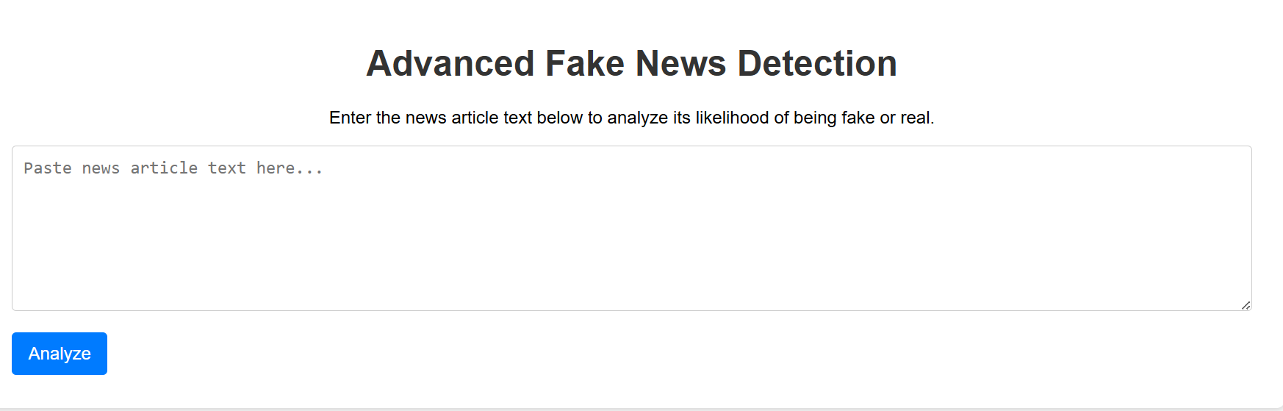

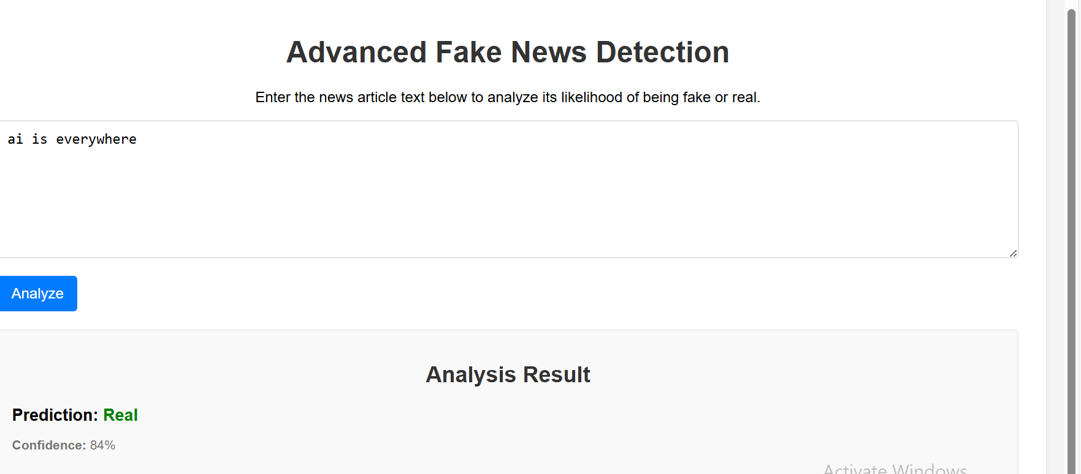

**13. Source code**

<!DOCTYPE html>

<html lang="en">

<head>

    <meta charset="UTF-8">

    <meta name="viewport" content="width=device-width, initial-scale=1.0">

    <title>Exposing the Truth: Advanced Fake News Detection</title>

    <style>

        body {

            font-family: sans-serif;

            margin: 20px;

            line-height: 1.6;

            background-color: #f4f4f4;

            color: #333;

        }

        header {

            background-color: #333;

            color: #fff;

            padding: 1em 0;

            text-align: center;

            margin-bottom: 20px;

        }

        header h1 {

            margin: 0;

        }

        .container {

            background-color: #fff;

            padding: 20px;

            border-radius: 8px;

            box-shadow: 0 2px 4px rgba(0, 0, 0, 0.1);

        }

        section {

            margin-bottom: 20px;

        }

        h2 {

            color: #333;

            border-bottom: 2px solid #ccc;

            padding-bottom: 5px;

            margin-bottom: 10px;

        }

        #detection-area {

            margin-top: 20px;

            padding: 15px;

            border: 1px solid #ddd;

            border-radius: 5px;

            background-color: #f9f9f9;

        }

        #detection-area label {

            display: block;

            margin-bottom: 5px;

            font-weight: bold;

        }

        #news-text {

            width: 100%;

            padding: 10px;

            margin-bottom: 10px;

            border: 1px solid #ccc;

            border-radius: 4px;

            box-sizing: border-box;

            font-family: monospace;

            font-size: 1em;

        }

        #detect-button {

            background-color: #5cb85c;

            color: white;

            padding: 10px 15px;

            border: none;

            border-radius: 4px;

            cursor: pointer;

            font-size: 1em;

        }

        #detect-button:hover {

            background-color: #4cae4c;

        }

        #result-area {

            margin-top: 15px;

            padding: 10px;

            border: 1px solid #ddd;

            border-radius: 5px;

            background-color: #e7f4e7;

            font-weight: bold;

        }

        .fake {

            color: red;

        }

        .real {

            color: green;

        }

        .explanation {

            margin-top: 10px;

            font-style: italic;

            color: #777;

        }

        footer {

            text-align: center;

            margin-top: 30px;

            color: #777;

            font-size: 0.9em;

        }

    </style>

</head>

<body>

    <header>

        <h1>Exposing the Truth: Advanced Fake News Detection</h1>

        <p>Leveraging Natural Language Processing to Combat Misinformation</p>

    </header>

    <div class="container">

        <section id="introduction">

            <h2>The Growing Threat of Fake News</h2>

            <p>In today's digital age, the rapid spread of misinformation, often referred to as "fake news," poses a significant threat to informed decision-making and societal trust. False narratives can quickly proliferate through social media and online platforms, influencing public opinion and potentially causing real-world harm.</p>

            <p>To combat this growing challenge, advanced technologies are being developed, including sophisticated fake news detection systems powered by Natural Language Processing (NLP).</p>

        </section>

        <section id="how-it-works">

            <h2>How Advanced NLP Detection Works</h2>

            <p>Natural Language Processing enables computers to understand and process human language. In the context of fake news detection, NLP techniques can analyze various aspects of text to identify patterns and indicators of misinformation. This can involve:</p>

            <ul>

                <li><strong>Sentiment Analysis:</strong> Determining the emotional tone of the text, which can sometimes be manipulated in fake news. For example, an article might use overly strong emotional language to sway readers.</li>

                <li><strong>Stylistic Analysis:</strong> Examining the writing style, grammar, and vocabulary used. Fake news might exhibit unusual or inconsistent writing patterns.</li>

                <li><strong>Fact-Checking Integration:</strong> Comparing the claims made in the text against verified information from reliable sources.</li>

                <li><strong>Source Credibility Assessment:</strong> Analyzing the reputation and history of the source publishing the information.</li>

                <li><strong>Linguistic Pattern Recognition:</strong> Identifying specific linguistic features often associated with fake news, such as hyperbolic language, appeals to emotion, or logical fallacies.</li>

                <li><strong>Topic Modeling:</strong> Understanding the main topics discussed in the text and identifying potential inconsistencies or unusual topic distributions.</li>

                <li><strong>Network Analysis:</strong> Examining how the information spreads and the characteristics of the accounts sharing it.</li>

            </ul>

            <p>By combining these and other NLP techniques, sophisticated systems can learn to identify fake news with increasing accuracy.</p>

        </section>

        <section id="detection-area">

            <h2>Detect Fake News Here</h2>

            <label for="news-text">Enter the news text you want to analyze:</label>

            <textarea id="news-text" rows="8" placeholder="Paste news article text here..."></textarea>

            <button id="detect-button">Analyze Text</button>

            <div id="result-area" style="display: none;">

                <strong>Detection Result:</strong> <span id="prediction"></span>

                <p class="explanation" id="explanation-text"></p>

            </div>

        </section>

        <section id="benefits">

            <h2>Benefits of Advanced Fake News Detection</h2>

            <ul>

                <li><strong>Improved Information Accuracy:</strong> Helps users distinguish between credible and unreliable information.</li>

                <li><strong>Reduced Spread of Misinformation:</strong> Can flag fake news before it reaches a wider audience.</li>

                <li><strong>Enhanced Public Trust:</strong> Contributes to a more informed and trustworthy information environment.</li>

                <li><strong>Support for Journalism:</strong> Allows journalists to focus on factual reporting by filtering out noise.</li>

                <li><strong>Protection Against Manipulation:</strong> Helps individuals and organizations avoid being influenced by false narratives.</li>

            </ul>

        </section>

    </div>

    <footer>

        <p>&copy; 2025 Advanced Fake News Detection Initiative</p>

    </footer>

    <script>

        document.addEventListener('DOMContentLoaded', function() {

            const detectButton = document.getElementById('detect-button');

            const newsTextarea = document.getElementById('news-text');

            const resultArea = document.getElementById('result-area');

            const predictionSpan = document.getElementById('prediction');

            const explanationText = document.getElementById('explanation-text');

            detectButton.addEventListener('click', function() {

                const textToAnalyze = newsTextarea.value.trim();

                if (textToAnalyze) {

                    // In a real application, you would send this 'textToAnalyze'

                    // to a backend server for NLP processing and receive a result.

                    // For this HTML example, we'll simulate a result.

                    const isFake = Math.random() < 0.5; // Simulate a 50/50 chance

                    resultArea.style.display = 'block';

                    if (isFake) {

                        predictionSpan.textContent = 'Likely Fake';

                        predictionSpan.className = 'fake';

                        explanationText.textContent = 'Based on our advanced analysis (simulated), this text exhibits characteristics commonly found in misinformation.';

                    } else {

                        predictionSpan.textContent = 'Likely Real';

                        predictionSpan.className = 'real';

                        explanationText.textContent = 'Based on our advanced analysis (simulated), this text appears to be consistent with credible information.';

                    }

                } else {

                    alert('Please enter some text to analyze.');

                }

            });

        });

    </script>

</body>

</html>

**14. Future scope**

While the current system effectively classifies news content as real or fake using textual analysis, there are several meaningful directions for future enhancements that can significantly improve accuracy, reliability, and adaptability:

#### **1. Multimodal Fake News Detection**

Future versions of the system can incorporate **images, videos, and metadata** (e.g., publisher, timestamps, user behavior) alongside text to better detect fake news. Since misinformation often uses doctored images or misleading video thumbnails, adding computer vision models to analyze visual content will make the system more robust.

#### **2. Real-Time News Stream Monitoring**

An advanced version of this project could integrate with live **social media APIs (Twitter, Facebook, etc.)** or RSS feeds to monitor and analyze breaking news in real-time. This would enable early detection of viral misinformation and alert authorities, journalists, or platforms before it spreads widely.

#### **3. Multilingual and Cross-Regional Support**

The current model may only support English text. Expanding the system to support **multiple languages and regional dialects** using multilingual NLP models (like mBERT or XLM-R) will help combat fake news on a global scale, particularly in countries where misinformation campaigns often go unchecked due to language barriers.

**4. Model Explainability and Bias Detection**

Adding **explainable AI (XAI)** techniques can help users and developers understand why a particular article was classified as fake or real. This increases trust in the system and allows for auditing potential **model biases**, especially if the model is trained on skewed or politically sensitive data.

**13. Team Members and Roles**

**Name and Responsibility**

N.J.Aparnapriya----- Data Cleaning, Preprocessing

Exploratory Data Analysis, EDA

N.J.Archanapriya----- Feature Engineering, NLP Pipeline

B.Kushalini----------- Model Development and Tuning

Documentation and Visualization